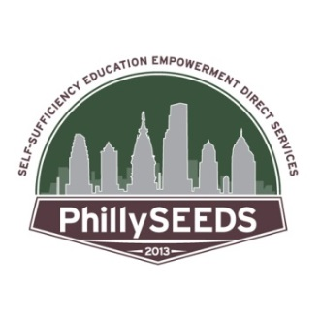
MANY THANKS TO OUR SPONSORS!

MOVING ON (Homeownership) SPONSOR
Internat’l Brotherhood of Electrical Workers Local 98

MOVING UP (Scholarships) SPONSOR
TN Ward

MOVING IN (Rental Deposit Assistance) SPONSOR
Edgemere Consulting
The HAI Group
Laborers Int’l Union of N. America Local Union #332
Santander Bank
T-Mobile
Witt-Hoey Foundation

TABLE + SPONSORS
District Council 21
The Michaels Organization

SUPPORTERS AND IN-KIND DONORS
The Alterra Group
Bartram’s Garden
Ceisler Media
Duvernay & Brooks
The Elmwood Park Zoo
Laborers Int’l Union of N. America Local Union #57

Our Featured Guests & Speakers Include:

MICHAEL HALL
Michael was raised in public housing in Philadelphia by his mother and grandmother, with his little sister. He became aware of family financial strains after his grandmother passed away and resolved to secure financial stability for himself and his family through his studies. With help from the PhillySEEDS scholarship fund, he graduated with a biology major from Lincoln University, is working in the medical field, and studying for the Medical College Admissions Test, with the goal of becoming a physician.

MARNET STONE
Marnet comes from a public housing-assisted family of nine, including six siblings who look up to her as a role model, due to her educational, professional and homeownership accomplishments. Marnet earned a Bachelor’s of Science and a Masters in Human Services at Lincoln University, has worked for the Juvenile Justice Center and the Defenders Association of Philadelphia, and in November of 2017, she purchased her own home with help from the PhillySEEDS matching down payment and closing cost program fund. Today Marnet is paying it forward by being a proud and award-winning FSS Financial Counselor at Clarifi, dedicated to the mission of empowering others.

BRENT CELEK
Former Philadelphia Eagles tight end and Superbowl LII Champion, in addition to his football accomplishments during his 11 year tenure with the Eagles, Brent Celek is the founder of the Take Flight Foundation and very supportive of non-profits, especially ones associated with education, in and around the Philadelphia area.

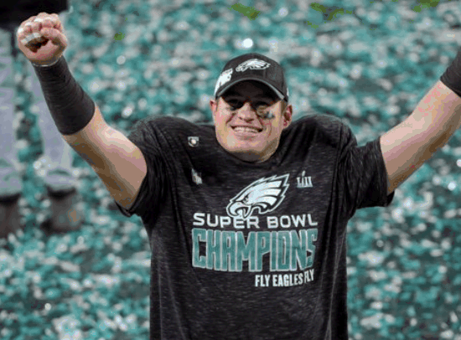

and, NOAH!
the official Philadelphia Eagles official live mascot is here to be photographed with you -- and PhillySEEDS thanks the Elmwood Park Zoo for making his participation possible!

